# 

# **ID2209 – Distributed Artificial Intelligence and Intelligent Agents**

# **Assignment 2**

# **Negotiation and Communication**

Group 12

Noémie Nicaise

Harshdeepsinh Parmar

16/11/2020

The objective of Assignment 2 is Navigation and Communication on the GAMA platform using FIPA Protocol (Request Interaction Protocol), in which one agent can request another agent to perform some actions or inform another agent about something. The interaction is based on the Dutch auction where the Auctioneer starts at a high price and reduces it in every round if no participant wants to pay for it. If the price reaches the reserve price, the auction is terminated.

**Approach to the problem and the challenge:**

There were three models that were created to implement the logic:

* Dutch_auction.gaml : To implement the dutch auction
* Multiple_dutch_auction.gaml : To implement multiple dutch auction
* Multiple_auction.gaml: To implement multiple auctions at the same time

**Implementation:**

According to the objectives of the assignment to introduce auction in the festival and engage the agents into buying different items by participating in that auction.

Dutch_auction.gaml Model comprises of two species

* Species participant: with the following important characteristics
  + Reflex receive_accept_proposals
  + Reflex receive_reject_proposals
  + Reflex get_informed
  + Reflex receive_cfp_msg
* Species Auctioneer: with the following important characteristics
  + Reflex announce_auction
  + Reflex receive_proposal
  + Reflex start_auction
  + Refle send_cfp_msg

These are the reflexes that help facilitate the communication between the agents when the circumstance arises when a participant is interested in an auction, goes to that auction and starts communicating. These reflexes follow the dutch auction protocol.

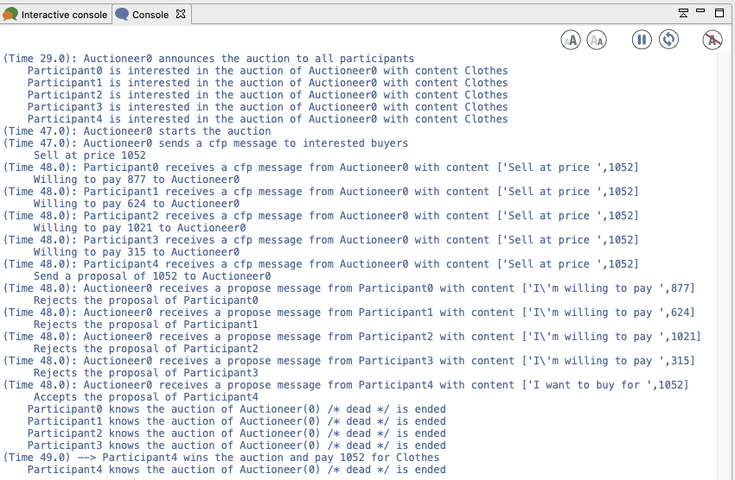

CHALLENGE 1: Multiple Auction in the festival:

Multiple_dutch_auction.gaml

This model facilitates multiple dutch auctions where participants can take part in the auction which sells the item they are interested in and then makes a bid on the item.

Special Characteristic about this model:

* Multiple dutch auctions at the same time
* Participants participate in auctions where their preferred item is sold
* Reflexes used in this model are the same as the last model

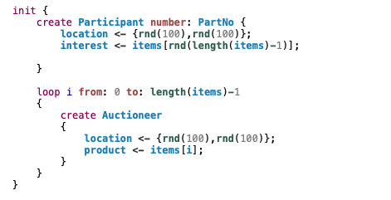

*Initializing this loop will create different auctions with different items on sale.*

Output:

As you can see multiple auctions are created and participants are interested and moving to their preferred auction.

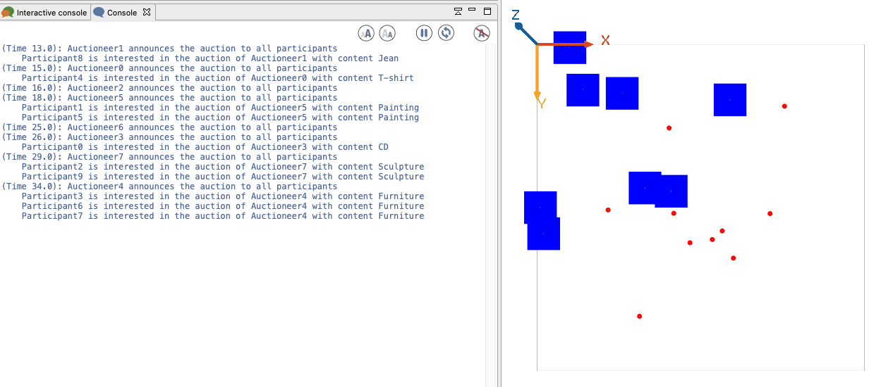

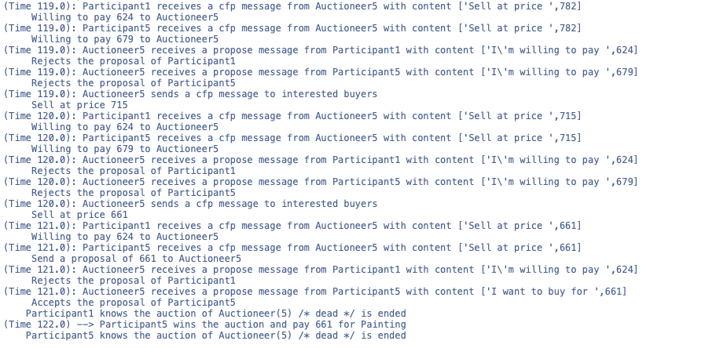

CHALLENGE 2: DIfferent auction settings

We approach this challenge by introducing different species such as

* EnglishAuctioneer
* SealedAuctioneer

By parenting it with the main Auctioneer Species.

The communication using FIPA and cfp remains the same between participants and auctioneers.

There is an attribute introduced “auctionType”, which will select one of the three available options and the communication will process likewise.

Output:

**Results and Conclusions**

Using FIPA Request Interaction Protocol Specification made us understand the communication between agents in the GAMA platform. The different characteristics involved in the part of communication such as, getting to know about the event, participating in the event agent prefers, sending the requests, accepting the requests and rejecting the requests made us thorough about the steps in communication, without which, the communication between the agent is not possible.

Also, introducing diversity in the models such as different auctions and the preference to choose what auction to go to depicted the real world scenario and taught us how to use this for a real world problem and solve them.